Mhd.Fadly Hasan

05111740000078

# Log tugas5

-Design Sprint 1

-Progress coding tahap 1/3

Output:

-logo aplikasi

-asset, bubble chat, chat system, chat dikirim, dan logo *money*

-Mock-up Sprint 1

-Codingan placeholder halaman ‘money’

Asset

## Logo



User bubble snet



Logo Money

Uset Bubble



Mock-up

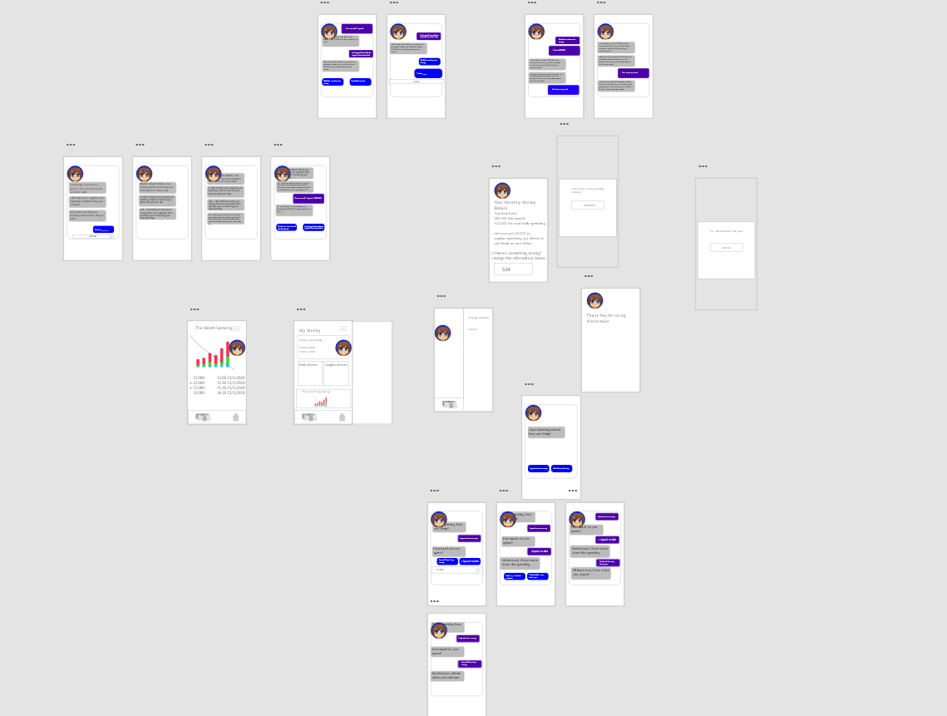

Dapat dikases di

<https://xd.adobe.com/view/5346a451-03ca-4580-6ba6-e69c7166dd33-2577/>

Progress codingan

